Induction Ceremony
Longhouse-New Members-Red Feather
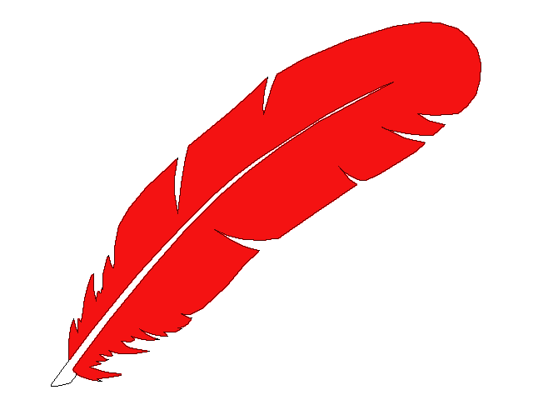
Overview: Induction ceremonies are typically held in the beginning moons of the program year and are primarily to honor new membership but it is also good to have all members reaffirm their pledge to the program and each other as well. This ceremony is generally written to be used in a group setting. The red feather in this setting is meant to symbolize the Feather of Love. There are a number of props required as mentioned within. All fathers and children are expected to wear the Native Sons & Daughters headband to the ceremony. This should be announced and encouraged in advance.

Participants:
- Chief: Ceremonial Leader
- Medicine Man (or Assistant Chief): Co-leader of ceremony
- Great Elder (or Sachem)
- (6) Young Braves (sons or daughters): Have been selected in advance and know which of the Six Aims they will be announcing. They should each have their portion of the script in hand.

Relevant Ceremonial Pieces: You may wish to incorporate this ceremony with other ceremonial components to form your full ceremony. The following are basic suggestions. Your creativity is your limit.
- Parade to Ceremonial Location
- Sacred Fire Lighting
- Officer Inductions
- Special Awards
- Ceremonial Closing

CEREMONY
Chief | (Raises Red Feather in hand) The red feather has been raised. Let there be silence in the Longhouse.
Drum Beater | (12 loud beats of the drum)
Chief | Let those who wish to speak, come before this Council fire
Medicine Man | (guides the processional of Chiefs and Officers)
Chief | (Loudly gives the Longhouse salutation)!
Medicine Man | Who speaks?
Chief | I (Chief Indian name) Chief of the (Longhouse name) Longhouse of Native Sons & Daughters. I wish to present these fathers and their sons for Induction. They have seen the power of the peace pipe. They have washed the war paint from their faces and the blood stains from their fingers. They have buried their war clubs and weapons. They desire to become brothers with other Native Sons & Daughters.
Chief | (Med Man Indian Name) Medicine Man of the Longhouse, I command you to deliver their message to the Great Elder who will listen to their plea to join Native Sons & Daughters.
Medicine Man | So be it, Oh Chief (fires flaming arrow in to the air)
Great Elder | Who speaks to me?
Chief | I (Chief Indian name) of the (Longhouse name) Longhouse of Native Sons & Daughters.  These braves before me have come to hear your message.
Great Elder | So be it. (walks to the Council Fire) Your request has been heard. Are you braves ready to stand the test and make the sacrifice for Induction?
Chief | My braves are ready to become my brothers.
Great Elder | Then let them come forward so we can hear their pledges of faith that represent our Six Aims.
Chief | (calls six pre-selected young braves by Indian Name, forward to present the pledge of the Six Aims
First Brave | Here is flint and steel used to make fire.  It reminds us to be Clean in Body and Pure in Heart
Second Brave | Here are two lengths of rope joined together with a common knot.  It reminds us to be Pals Forever-Friends Always with our dads.

Third Brave | Here is the headband of our program with its symbols to remind us of family, the Great Spirit and all of his creation. It reminds us to Love the Sacred Circle of our Family.
Fourth Brave | Here is a red feather. This, when held high by the Chief, brings silence to the Longhouse. It reminds us to Listen While Other Speaks.
Fifth Brave | Here is an ear of corn, a food given to us by the Native Americans who would share it with their needy neighbors. It reminds us to Love our Neighbor as Ourselves.
Sixth Brave | Here is a bow and arrow, weapon of the Native American Indian. It reminds us to Seek and Preserve the Beauty of the Great Spirit’s Work in Forest, Field and Stream
Chief | Braves, your tokens are most acceptable. (Med Man Indian Name) our Medicine Man… is the ceremonial urn ready for the sacrifice?
Medicine Man | (Waves a medicine stick over a ceremonial urn or bowl that is already lit and discretely drops a small amount of gun powder/flash powder into the urn so that it flares up.
Medicine Man | You have heard the Six Aims our program. Now I tell you that these Aims are not possible for a father who is selfish or a son who is impatient. As a final step to joining the brotherhood of Native Sons & Daughters, I call upon each one of you to sacrifice those evil traits… the father to let his selfishness be burned away in the sacred fire, and the son to abandon his haste for things to happen and let his impatience also be burned away in the sacred fire
Chief | New Big Braves, as the drum beats, take a birch bark chip and throw it onto the sacred fire as a sacrifice of the trait of selfishness and replace it in your heart with understanding. (Drum beats start, Big Brave inductees come forward, receive a chip then circle around the fire. They then in unison throw their chip into the fire. When all are done, drum beats stop. Big Braves stay in place.)
Chief | New Little Braves, as the drum beats, come forward and join your fathers. Take a birch bark chip and throw it onto the sacred fire as a sacrifice of the trait of impatience and replace it in your heart with thoughtfulness. (Drum beats start, Little Brave inductees come forward, receive a chip then circle around the fire. They then in unison throw their chip into the fire. When all are done, drum beats stop.)
Medicine Man | Ho’sa, Ho’sa, Well done!! New braves, please return to the circle.
Chief | These braves have indeed heard the call of the Great Spirit, and they have learned well, the Aims and Ideals of Native Sons & Daughters. The fellowship they seek is the true devotion and understanding between father and son, which we call “Pals Forever-Friends Always”. Therefore, we are truly brothers.

Medicine Man | (Chief Indian Name) as Chief of the Longhouse, please bestow the gift upon both the new and returning the Big Braves and their Sons & Daughters.
Chief | (Holds a Red Feather high in the air) This feather is unique to our Longhouse. It symbolizes our union and our concern for one another. Wear it proudly.  (A feather is presented to all members)  Let each Big Brave (father) place the feather in his Young Braves (sons or daughters) headband. (wait)  Let each Little Brave place the feather in his Big Braves headband. (wait)  You now wear the Longhouse Feather of Love. Wear it proudly! May it bring everlasting love to your teepee’s
 | CLOSING OF CEREMONY AS DESIRED
Contributed by: unknown

